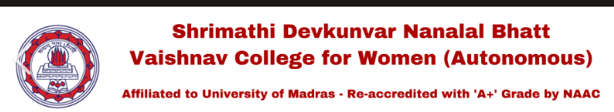
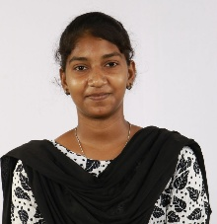
PROJECTS
AI Healthcare Chatbot | Python, Flask, HTML, CSS, JavaScript, NLP
• Developed an AI-powered chatbot to answer healthcare queries using NLP and Flask
AI Voice Translator Chatbot | Python, Flask, Speech Recognition, Translation API
• Built a multilingual chatbot with real-time speech-to-text conversion and language translation.
Online Ticket Booking Website | HTML, CSS, JavaScript
• Developed a responsive ticket booking website with dynamic booking and form validation features.
Fire Fighting Robot | Arduino, Embedded C, Flame Sensor, IoT
• Designed an autonomous fire-fighting robot with flame detection and automated motor navigation.
CERTIFICATES
• Microsoft Certification
• Infosys Springboard Certification
• UiPath Certification
• Simplilearn Certification
• EF SET English Certification

TECHNICAL SKILLS
Programming Languages: Python, Java
Web Development: HTML, CSS, JavaScript, Bootstrap, Flask (Basic), Node.js (Basic)
Database Management: SQL, MySQL
Artificial Intelligence: Machine Learning (ML), Artificial Intelligence (AI), Natural Language Processing (NLP), Computer Vision
Tools & Technologies: Git & GitHub, Power BI, Jupyter Notebook, Visual Studio Code (VS Code)

Internship
AI & Machine Learning Intern – Meg World Technologies | May 2026 – June 2026
- Worked on Artificial Intelligence and Machine Learning projects using Python.
- Built practical AI applications and improved analytical and problem-solving skills.
- Collaborated with mentors on industry-oriented software development workflows.

OBJECTIVE
Computer Science undergraduate specializing in Artificial Intelligence with strong skills in Python, SQL, Java, and frontend technologies. Passionate about problem-solving, emerging technologies, and building impactful solutions while continuously growing professionally.
 deepa251124@gmail.com
+91 9382185609
 M-DEEPA-HUB
 https://www.linkedin.com/in/deepa-deepa-978b0432b
ACADEMICS
Bachelor of Science in Computer Science with Artificial Intelligence
Shrimathi Devkunvar Nanalal Bhatt Vaishnav College
2024 – 2027 (Pursuing)
Percentage: 80%
Higher Secondary (12th Grade)Christ King Girls Higher Secondary School
Percentage: 84.3%
Secondary (10th Grade)Valluvar Gurukulam Higher Secondary School
Percentage: 93.8%

DEEPA M
Certification Badges
